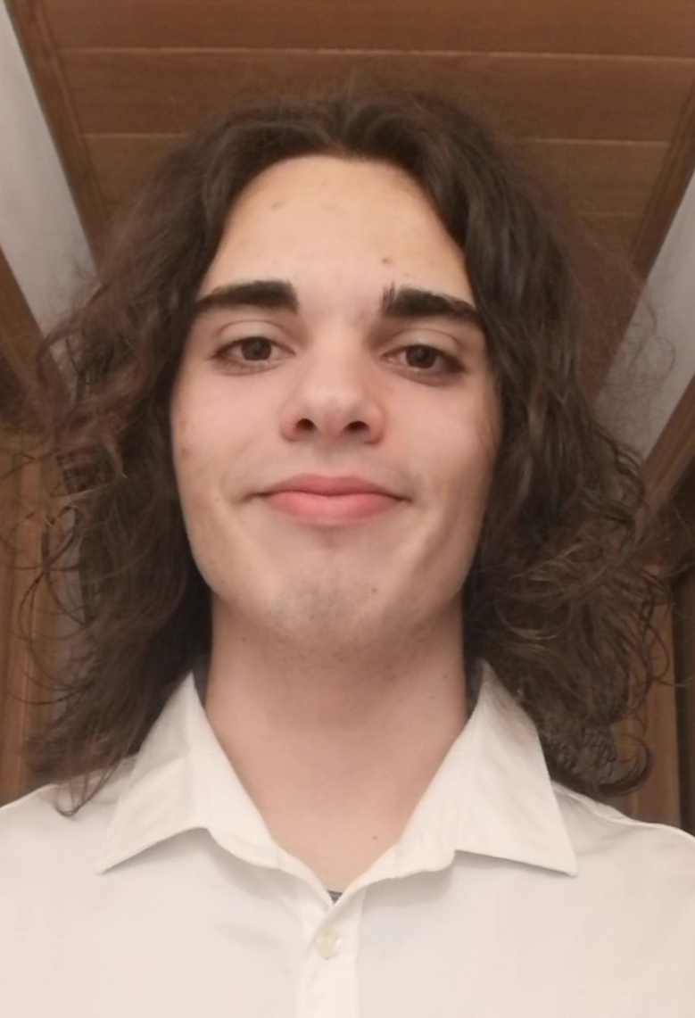
MARIO RUIZ CAMUÑAS
CONTACT INFORMATION  PERSONAL COMPETENCES  t  LANGUAGES  SOFTWARE |  | PROFESSIONAL OBJECTIVE  I am a second-year student at CFGM Sistemas microinformatic i xarxes, now I am looking for a job to be able to put into practice the knowledge I have obtained.  This course has helped me learn to work in a team, help my colleagues and take initiative.  I have participated in several volunteering  TRAINING  2020-Cursing, CFGM Microinformatic Systems and Xarxes,  Bellvitge Jesuits. Study Center Joan 23  2016-2020, compulsory secondary degree. (ESO)  Bellvitge Jesuits. Study Center Joan 23  2021-2022, practicas escuela Balaguer  PROFESSIONAL SKILLS  Assemble and setting up computers and peripherals, ensuring their operation in quality and safety conditions.  This year (2022) I did an internship at the Balaguer study center in Torrasa and it helped me a lot to learn a little more about working life. I learned how to assemble and disassemble computers, fix screens, set up computers, set up printers, and help set up the school's internet.  NON-WORK ACTIVITIES In 2019  I did a volunteer job, the volunteer job was to train 1st and 2nd grade children who played futsal.  As a hobby, I play in two futsal teams. I'm playing for ONCE as a volunteer and for Bellsport in Bellvitge, I'm a goalkeeper and captain of my Bellsport team.
   | Hospitalet de Llobregat, Barcelona, Catalunya.  (08901)
   | +34 657 33 58 38
  . | Marioruca2004@gmail.com
   | Aprendiendo | Competente | Experto
  Autonomy | 
  Initiative | 
  work organization | 
  Teamwork | 
  Communication | 
  Flexibility to changes | 
  Commitment | 
  Leadership | 
   | Inicial | Intermedio | Avanzado
  Spanish | 
  Catalan | 
  English | 
   | Aprendiendo | Competente | Experto
  Image and video editing | 
  Programming | 
  Packet tracer | 
22/04/2004

